JSX combines HTML, CSS and JavaScript into one single block of code. Why did React come up with this idea in the first place?

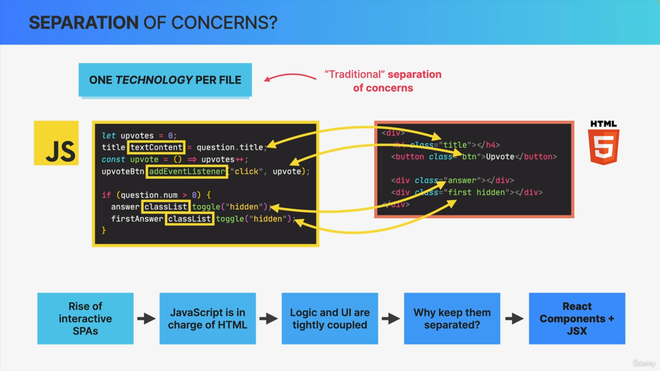

Before the rise of single page applications, we have one file for HTML, one file CSS and one file for JAVASCRIPT i.e. one technology per file. This was our traditional separation of concerns.

However, as pages got more and more interactive, they became single page applications where the JavaScript started to determine the user interface and the content in general. In other words, JavaScript became more and more in charge of the HTML.

We can see that here in this really small code example where the content and the presentation of these HTML elements are really completely determined by the JavaScript code. They are tightly coupled together.

So, the HTML doesn't even make sense without the JavaScript here.

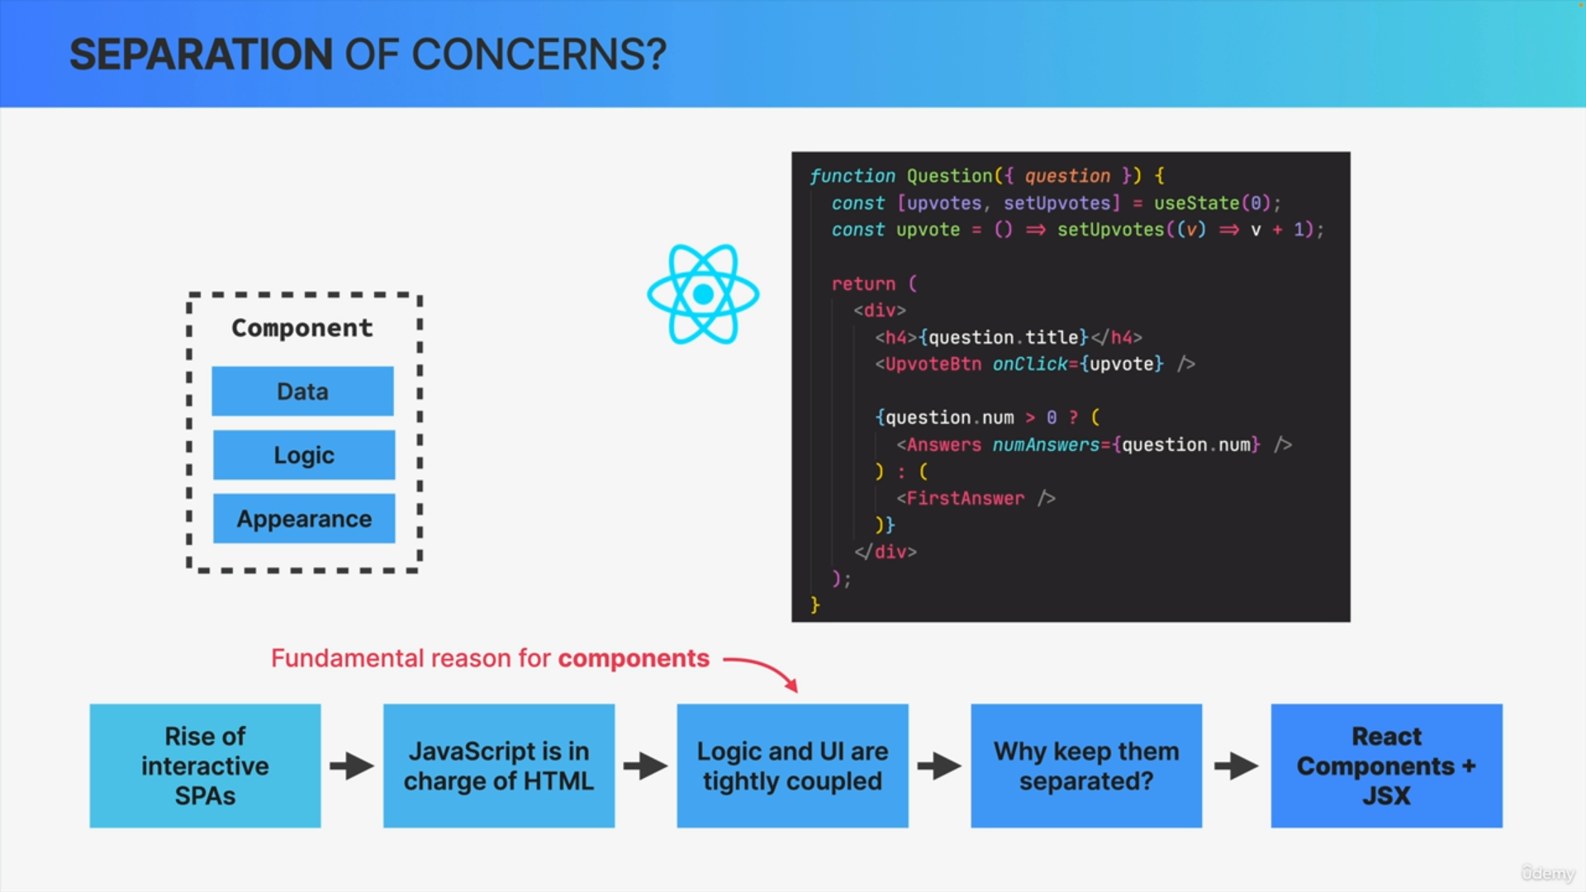

If the JavaScript is in charge of the HTML anyway, so if the logic and the UI are so tightly coupled together, then why should we keep them separated in these different files and in different code blocks?

The answer to this question is what gave us React components and JSX. The logic and UI are so coupled in modern web applications, is really the reason why a React component contains the data, the logic and the appearance of one piece of the UI.

It's the fundamental reason why REACT is all about components.

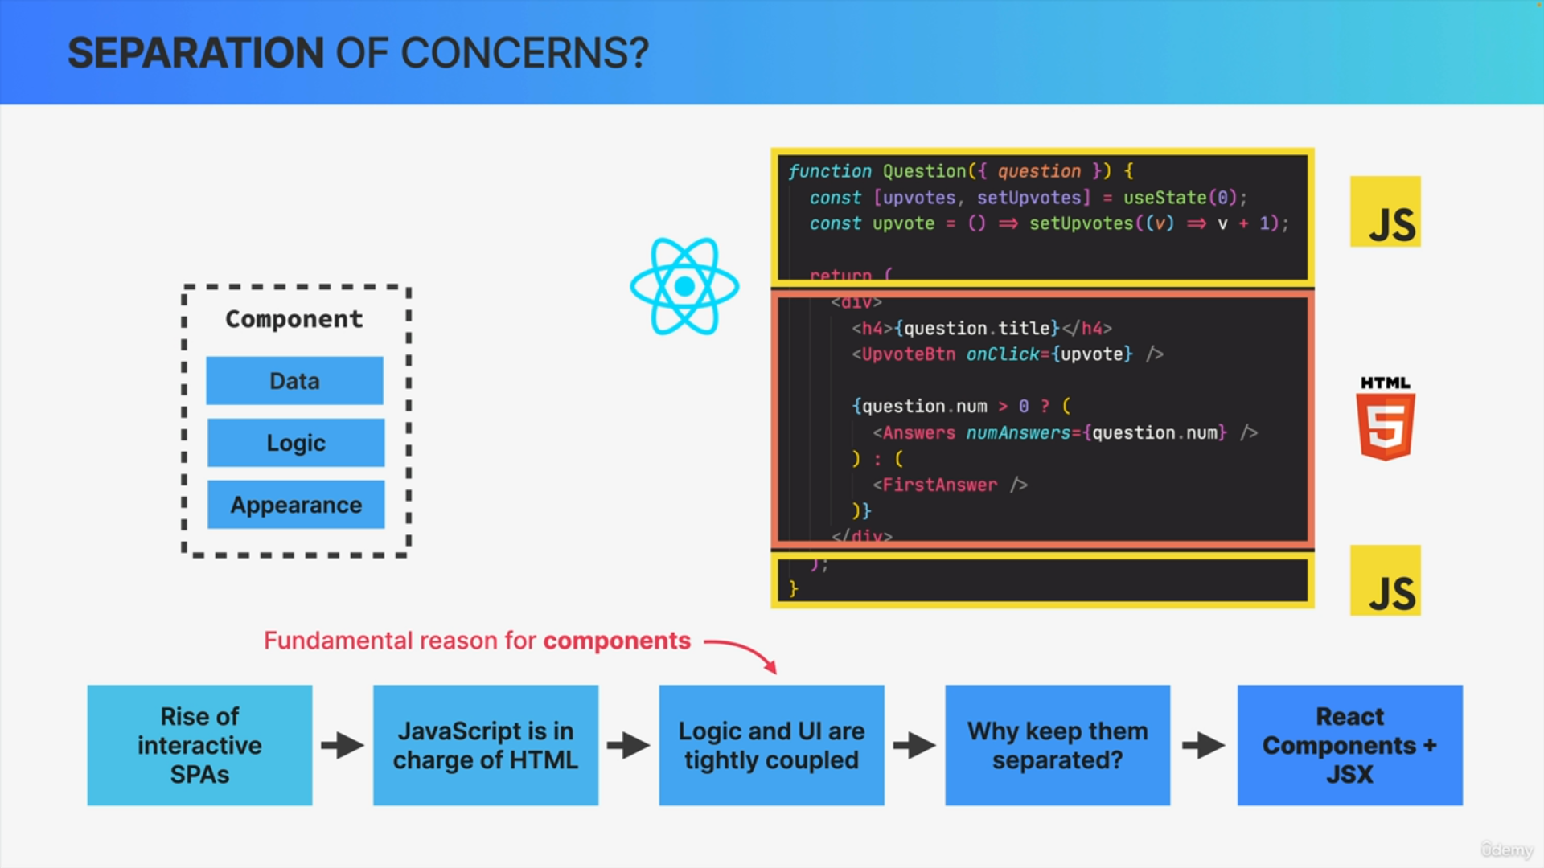

In this React example we can see how JavaScript and HTML markup coupled together in this one single component.

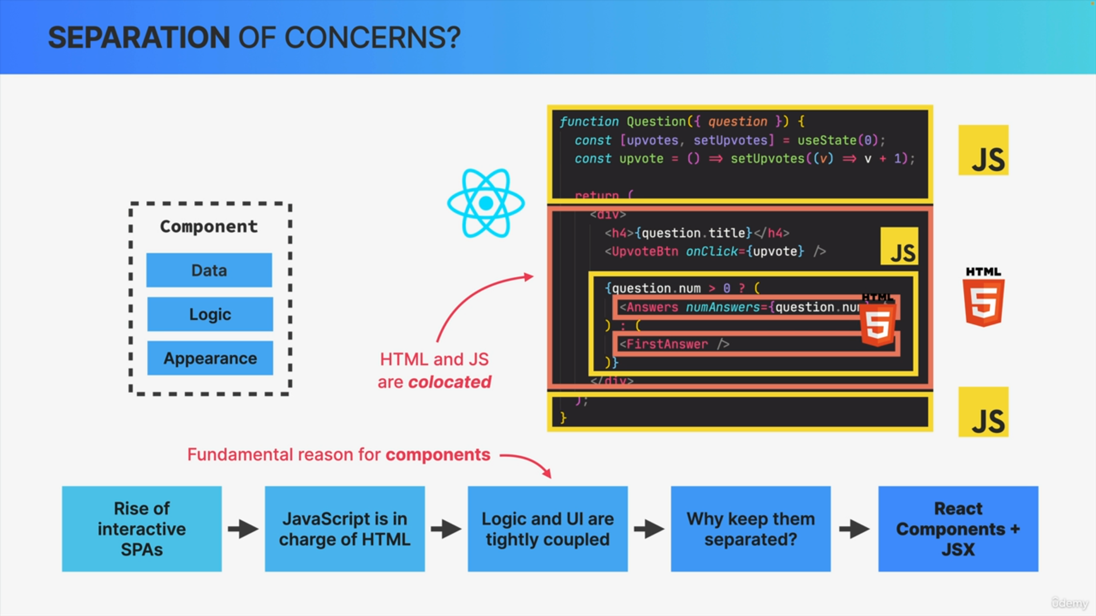

This component has some JavaScript logic, it has JSX and then inside that JSX, there is yet another block of JavaScript, which in turns has even more JSX inside of it.

So, everything is mixed together but it all still works really well. So, content and logic are tightly coupled together and it makes sense that they are co-located here.

Co-located simply means that things that change together should be located as close as possible together.

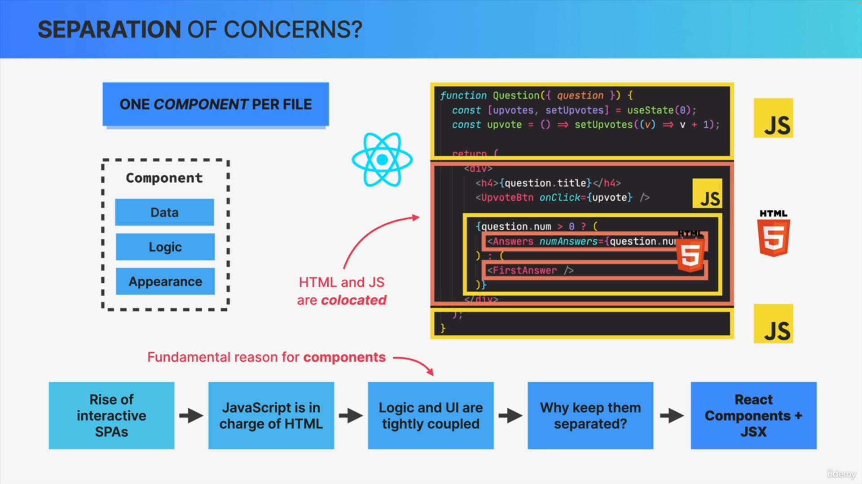

In case of React apps, this means that instead of one technology per file, we have one component per file. So, one component that contains data logic and appearance all mixed together.

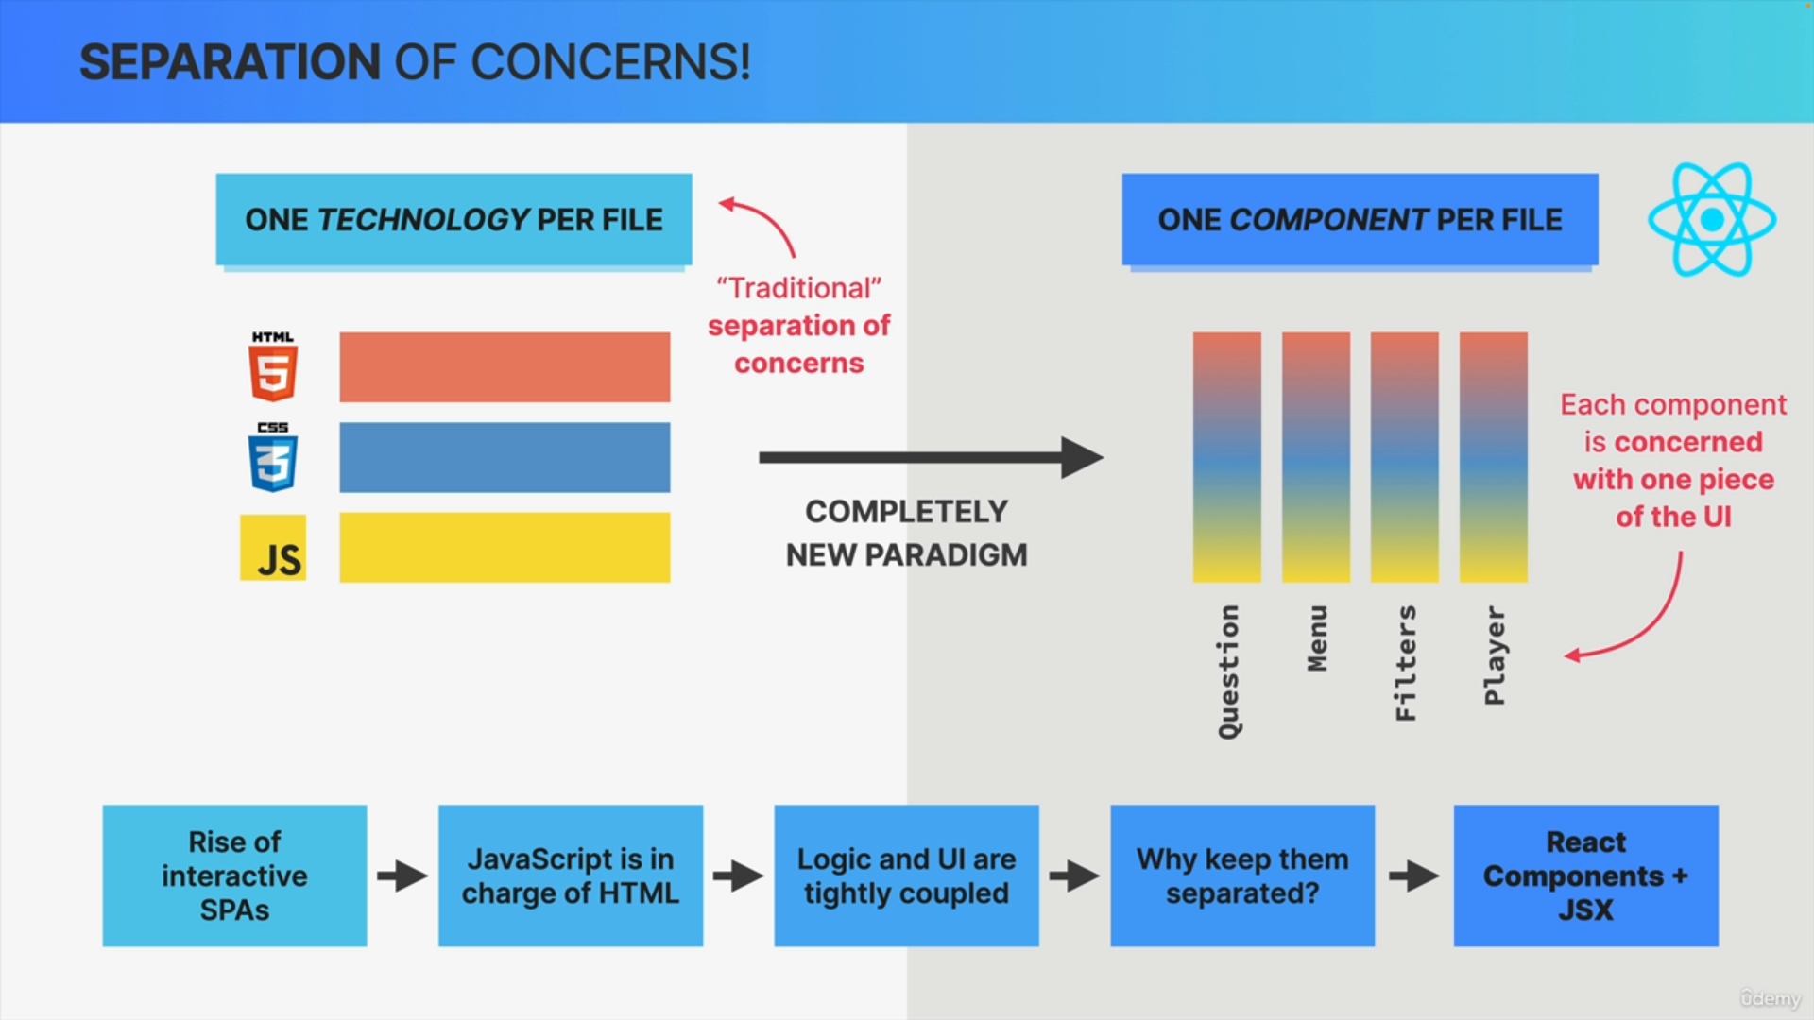

React has one concern per component. Each component is concerned with one piece of the UI.